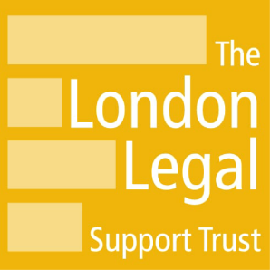

Social Media Guidance
London Legal Support Trust has a number of different social media channels to allow us to communicate directly with individuals, organisations and communities who are interested in supporting access to justice through fundraising, knowledge sharing, collaboration and grants.
We want you to engage with us on social media, but we do expect the same level of courtesy that we offer you, so we have a short set of ‘house rules’.
Please do:
comply with the social media platform’s (i.e. Facebook, X, Instagram etc) terms of use, as well as these terms of use -
only post information you’re happy for everyone to see
keep your posts on topic
keep the language appropriate
share our posts with your friends and family
Please don’t:
post personal information, such as phone numbers or addresses
post anything unlawful, defamatory, embarrassing, or damaging to someone’s reputation, libellous, abusive, threatening, harmful, obscene, sexually oriented or racially offensive
bully, harass or intimidate any individual or organisation
spam or troll our social media accounts (i.e. post persistent negative or abusive posts designed to provoke a response)
post the same message, or a similar message, repeatedly
promote or advertise other services on our channels
We will remove, in whole or in part, or ignore posts that we feel are inappropriate and break our house rules.
We will remove, block, ban and / or report any user to the associated social media platform who:
repeatedly violates our house rules
uses an offensive image as their profile picture
has an offensive username
Monitoring and responding
We monitor our main accounts Monday to Friday from 9:30am – 6.00pm. We read all messages and reply to them where appropriate, but we can’t reply to every message we receive.
If there are any requests for legal advice, we will direct you to external advice providers. However, we do not provide legal advice of any kind.
Likes, follows and shares
We carefully choose who we follow, like and share content from, but we cannot follow, like or share everything requested or received.
We sometimes follow, like or share content from other organisations or individuals that we think will be of interest to our followers, but this doesn’t mean that we endorse the originating person or organisation.
We reserve the right to modify or change our house rules at any time
What to do if you see something that doesn’t look right
Should you spot any content or comments posted on our social media channels, which you believe is not in accordance with these house rules, the terms and policies of the social media channel concerned or the terms and conditions of our website, then please report it to info@llst.org.uk
Last updated: 26th September 2023

